2026 INCITE Project Closeout Report
Date Submitted: xx-xx-xxxx
A. General Information
Project Name:
Principal Investigator (PI):
PI Institution:

Utilization (OLCF will complete this table)

Allocation Year | Total Allocation | Frontier Final Usage | Andes Final Usage
2025 | 766,000

B. Project Results

Executive Summary
Summary here.
Summarize the significant scientific and/or engineering accomplishments achieved through this INCITE award.
Summary here.
Describe how access to leadership computing resources, data capabilities, your liaison, and/or staff at the Oak Ridge Leadership Computing Facility (OLCF) enabled these results.
Input text here.
C. Application Performance
Primary code(s) used by this project
Input text here.
Application Performance
Summarize the performance (e.g., percent of peak, scalability) of your project's simulation codes used in the allocations for this project.
Input text here.
What progress was made in improving the application's performance on LCF architecture during this project?
Input text here.
What challenges (if any) remain?
Input text here.
List the technical risks and challenges that were confronted by your project (overcome or not) this year. Were they anticipated?
Input text here.
Leadership Usage (OLCF will complete this table)
Allocation Year | Percent of Usage from Batch Jobs Requesting Less than 20% of Systems’ Available Resources | Percent of Usage from Batch Jobs Requesting Between 20% and 60% of Systems’ Available Resources | Percent of Usage from Batch Jobs Requesting Greater than 60% of Systems’ Available Resources
2025 | — | — | —

D. Impact of Research
Impact Statement
Input text here.
Technical Accomplishments
Input text here.
Publications and Presentations
Published
Input text here.
Accepted
Input text here.
Submitted
Input text here.
Invited Talks
Input text here.
Presentations
Input text here.
Software Releases
Input text here.
Dissertation
Input text here.
Post-doctoral Fellows and Students
Input text here.
E. Highlights

xx produced an OLCF highlight related to this work.
[Insert Photo]
F. One-Page PowerPoint (PPT) Elements

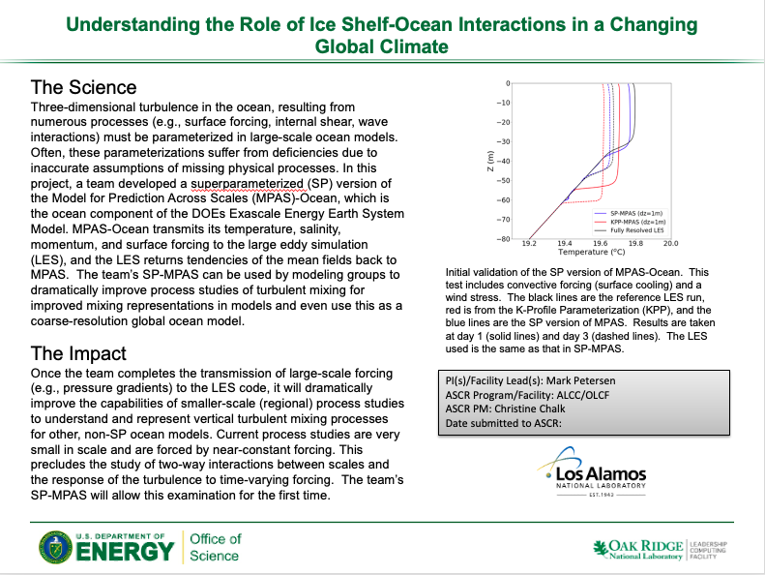
The OLCF is required to provide DOE with a one-page PPT slide at the closeout of your INCITE project. Please provide the following elements so that we can create the PPT slide which will be similar to the one seen in the figure to the right.

  - The Science – Please describe in no more than 4 to 5 sentences the overall science goal of your INCITE campaign.
  - The Impact – Please describe in no more than 4 to 5 sentences the overall impact of your INCITE project to-date. Try to link it to the specific accomplishments of this project and the impact this project could have on the research community and/or the community at large, to the sponsor, scientific discovery, and/or translation of outcome to new areas.
  - Image – Please provide an image for your project.
  - Caption for Image – Please provide a short caption for your image and include any necessary attributions for the image.
  - Related Publication Citation if applicable

